**REACT JS**

* React is JavaScript library.
* Designed by Jordan Walke, who is software engineer at Facebook.
* It was first deployed for Facebook news feed around 2011.
* In 2013 , react was open sourced at JS conference. (It means how to developed the react code is available on github. Professional can suggest the changes).
* Component based approach
* npm install -g create-react-app command is for global install react app.
* create-react-app --version is for know the react app version.
* Create-react-app <projectname> command for create react project.
* We can close component tag as like html tag but do things as simple we close component like <Hello/>

**Var,Const,Let**

* Let is block scope,var is function scope  
  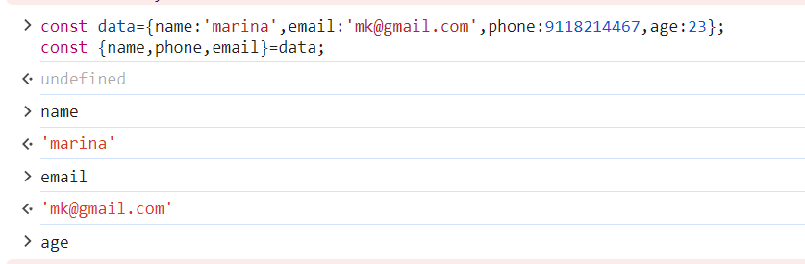
* 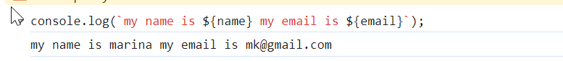

**Parameter and Default Argument**

* 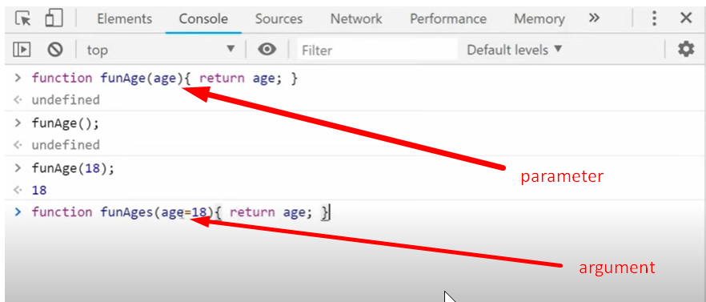

**Object Properties**

* It means if we define any object before using const we use it again as we want for example –

Const obj = {name:’marina’ , email:’mk@gmail.com’};

Const shortobj = {name,email};

Console.log(shortobj);

**Arrow function**

* 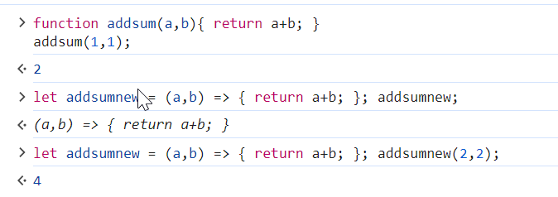
* Javascript created in 1996.
* In 1997, it was submitted to ecma international for standardization which resulted in ecmaScript.
* In 2015 , it was updated to ES6.
* In 2016, it was updated to ES7.
* In 2017, it was updated to ES8.

**JSX**

* JSX stand for JavaScript extension, which enables to write html with javascript.
* For example

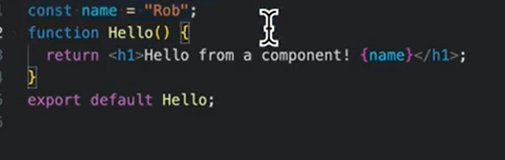

**Reusability**

1) One Component can be use anywhere.

2) If there is an issue coming we have to check that one component.

**Props**

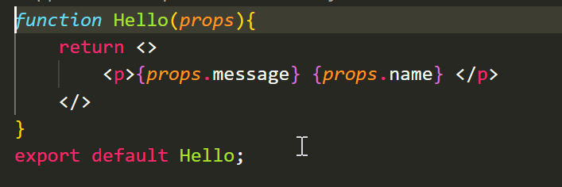

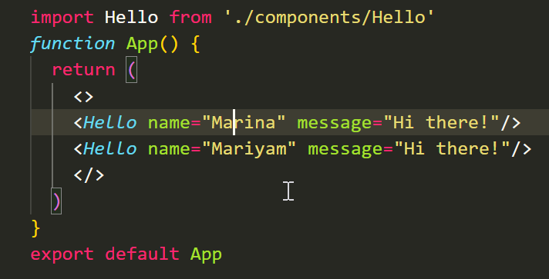

**Destructuring Props**

* Props are immutable means we can’t change the value of defined props.

**Map**

* Map is use to loop any data.

**Props vs State**

* Props value cannot change
* But in stats we can change the value when we need
* Stats is an object

|  |  |
| --- | --- |
| Props are passed to  component | State is contained inside the component |
| Props are immutable | State can be changed |
| Props are like parameter pass to the function | State is like a variable declared in function body |